Silicon Graphics
Silicon Graphics, Inc.
2011 N. Shoreline Blvd.
Mt. View, CA 94043
Phone (800) 800 7441

..........
.
.
.
.
.
..
.
.
.

.
.
.
.
.
.
.
.
.

DDK Guide for IHVs

Version 0.3

November 18, 1997


.
.
.
.
.
.
..
.
.

OpenGL DDK
DDK guide for IHVs

Copyright © 1997 Silicon Graphics, Inc.

This document contains unpublished information of Silicon Graphics, Inc.

This document is protected by copyright, and contains information proprietary to Silicon Graphics, Inc. Any copying, adaptation, distribution, public performance, or public display of this document without the express written consent of Silicon Graphics, Inc. is strictly prohibited. The receipt or possession of this document does not convey any rights to reproduce, disclose, or distribute its contents, or to manufacture, use, or sell anything that it may describe, in whole or in part.

U.S. Government Restricted Rights Legend

Use, duplication, or disclosure by the Government is subject to restrictions set forth in FAR 52.227.19( c )(2) or subparagraph ( c )(1)(ii) of the Rights in Technical Data and Computer Software clause at DFARS 252.227-7013 and/or in similar or successor clauses in the FAR or in the DOD or NASA FAR Supplement. Unpublished rights reserved under the copyright laws of the United States. Contractor/manufacturer is Silicon Graphics, Inc., 2011 N. Shoreline Blvd., Mountain View, CA 94039-7311.

OpenGL is a trademark of Silicon Graphics, Inc.
.
.
.
.
.
.
..
.
.

Table of Contents

Forward 5
Intended Audience 5
Source Code 5
Contacting Us 5
Conventions 6
Documentation Conventions 6
Code Naming Conventions 6
DDK Contents 7
Introduction 8
This DDK Version 8
Execution Path 8
Architecture 9
IHV deliverables 10
Software Organization 11
OpenGL Structure (oglpc) 11
Directories 13
Recipe for an ICD 15
The 6 steps to creating your ICD 15
Collect Information 15
Modify the 2D Driver (kernel mode) 15
Provide Basic Hardware Access 17
Add wgl functions 17
Add 3D Accelerated Functions 18
Testing your ICD 19
PICKPROCS 20
Sample Driver Functions 21
S3context.c 21
s3pick.c 23
s3pxlfmt.c 24
s3tri.c 26
s3vdevice.c 26
s3vmap.c and s3vmapicd.c 26
Texture Manager 28
__glDDrawInitTextureManager 28
__glDDrawReleaseTextureManager 28
__glDDrawInvalidateTextureManager 28
TexMgrCreateTexture 28
TexMgrDeleteTexture 28
TexMgrMakeResident 28
__glDDrawCreateTexture 28
__glDDrawFreeTexture 28
__glDDrawTextureMakeResident 28
__glDDrawMipMapSlurp 28
__glDDrawMipMapSlurpSubImage 29
Known Bugs and Limitations 30
Bugs 30
Tested Hardware 30
Extensions 31
Non-optimized Paths 31
Glossary 32
References 33
Documents 33
Benchmarks 33

.
.
.
.
.
..
.
.
.

Forward

Intended Audience
This document is intended to assist OpenGL IHVs in quickly implementing an OpenGL ICD. Specific emphasis is placed on the steps required for an IHV to integrate its unique 3D functionality into this ICD implementation. This document does not address specific hardware features, since these may vary from vendor to vendor. However, a discussion of a common subset, such as points, lines and triangles, is included.

Source Code
For more detailed and specific information, the reader should refer to the source code of the included S3 Virge sample driver. This is where implementation details of register mappings, detailed function interfacing and a working example can be found. It is expected that only a combination of studying the sample driver and review of this documentation will provide the necessary information to produce a successful implementation.

Note
This document was written at the same time that the DDK was under development. Variations between the documentation and the code distribution do exist. This document is intended as a guide and not as an absolute reference.
Be sure to also read the release notes included with the DDK.

Contacting Us
Requests for assistance with this DDK and comments on this documentation may be sent to win-ogl-ddk@engr.sgi.com.

Conventions
.
.
.
.
.
..
.
.
.

Documentation Conventions
Comments of interest to some, but not within the primary focus are notated with the sidebar standout.

Code Naming Conventions
- All application accessible names begin with gl or GL_
- All other internally globally visible internal names begin with __gl or __GL
- Function names and variable names begin with __gl
- Type names, struct tags, enumerations, and #define macros begin with __GL
- Mixed case is used to separate words within names, except for macro and enum names which should be all caps and use underscore as a separator
- For device specific names, the __gl or __GL should be followed by a device specific identifier

Examples:

__glim_Vertex3fv | generic immediate mode
__gllc_Vertex3fv | generic list compilation mode
__glle_Vertex3fv | generic list execution mode
__glce_Vertex3fv | generic list compile-execute mode
__glx_Vertex3fv | generic remote rendering
__glPickAllProcs | generic PickAllProcs routine
__glsS3PickAllProcs | S3 specific version of PickAllProcs
__Glcontext | generic context type
__GLS3context | S3 specific context type
__GL_MAX_WINDOW_HEIGHT | generic #define constant

DDK Contents
.
.
.
.
.
..
.
.
.

This DDK Kit does contain:
- The entire source tree for OpenGL for Windows. This includes the geometry pipe (transforms, clipping, lighting, etc.), the software rasterizer (points, lines, triangles, bitmaps, dithering, etc.) and window management (wgl functions). The source tree for OpenGL resides in the /opengl directory.
- A sample device driver (for S3). This sample illustrates a sample implementation and integration of driver code into the OpenGL for Windows source tree. This sample driver may be found in the oglpc/opengl/drivers/s3 directory in the DDK distribution.
- ICD specific code, except glcltpt.c, is contained in ogl.obj.
- OGtest is included for testing your driver.

The DDK does not contain:
- The Microsoft specific documentation on a MS compliant OpenGL ICD. This information is contained as part of the Microsoft ICD Kit and may be obtained under license from swright@microsoft.com.
- ICD specific code by SGI. This code is referred to in this document as glcltpt.c. This code will be included in a future release of the DDK, pending resolution of some implementation specific issues.
.
.
.
.
.
.
..
.
.

Introduction
.
.
.
.
.
.
..
.
.

This DDK Version
This DDK is an early “fast track” release. In this DDK release, you will find everything necessary to produce an opengl.dll with hardware acceleration as well as a hardware accelerated ICD. The ICD specific code servicing OPENGL_GETINFO and DIB_Control is located in ogl.obj.

Execution Path
Since multiple software renderers (Microsoft and SGI) and multiple OpenGL configurations may exist on a machine, we need to consider what paths will be executed under differing environments. Which OpenGL is executed depends on the setting of the pixel format descriptor (PFD) flags for OpenGL 1.1. This PFD list is set by the hardware manufacturer. In general, the results below are expected when both OpenGL implementations are resident on the machine.
- For software rasterization, the Microsoft implementation is used unless the application is explicitly linked with the SGI library. This SGI library, called OpenGL.lib, instead of Microsoft’s OpenGL32.lib contains the SGI optimized rasterization software.
- For hardware rasterization under Win95, an ICD must be present. OpenGL will defer all rasterization to the ICD hardware driver for any accelerated pixel formats. When a pixel format is chosen that the hardware does not accelerate, the Microsoft software rasterizer inside opengl32.dll is used as the fallback. If a state (or primitive) is chosen which is not hardware accelerated, within a pixel format that is accelerated the ICD software rasterizer is used as the fallback.
- For hardware rasterization under Win/NT, a MCD may be present. (ICD acceleration is also possible under Win/NT). OpenGL will defer all rasterization to the hardware driver. Hardware acceleration will only occur when the pixel format is supported by the hardware and the current rendering state is supported. Otherwise, drawing will take the software rasterization path. Regardless of how the application is linked, when an MCD is present, software rasterization will use the Microsoft OpenGL.
Below is a driver’s point of view of how both Microsoft’s and SGI’s OpenGL are configured on a PC.
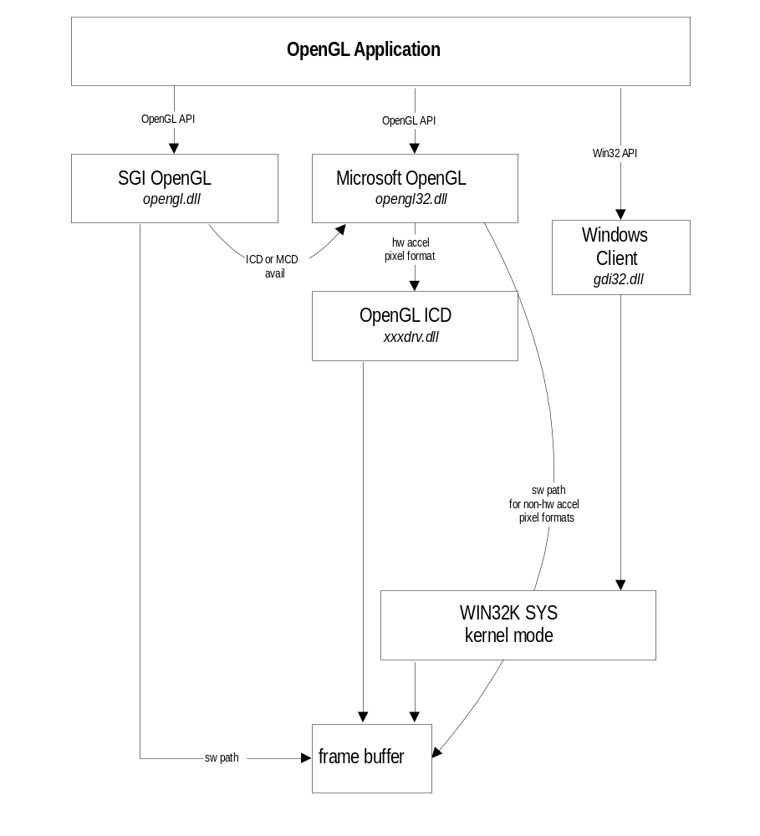

NOTE: MCD driver not show in illustration above

Architecture
The OpenGL DDK is composed of a hierarchy of multiple functional units. These include the wgl functions, the geometry pipeline, the rasterizer and the sample driver.
The SGI DDK provides all the software necessary to produce either an OpenGL dll (opengl.dll) or an ICD driver (xxxdrv.dll) with hardware acceleration. In addition, a sample driver, for S3 is included. Your final product will take advantage of SGI’s high performance geometry pipeline. The software contained in the DDK Kit has been specially optimized for the game and 3D on-line market arenas.
Conceptually, there are two distinct issues in regards to writing an OpenGL ICD; the OpenGL hardware interface and the ICD loading mechanism. Although this text will often discuss both of these issues intermixed, it is helpful to remember that it is possible to write an OpenGL hardware interface (using the ICD software) without the ICD loading mechanism. Although it may be desirable to create an accellerated OpenGL dll in the short term, for testing purposes this particular path is not desirable in the long term, since it requires the distribution of a proprietary opengl.dll.
The device driver is composed of a few distinct sets of functions; core, wgl and ICD loading. The core functions are the routines that draw primitives to the screen (triangle, point, line, bitmaps). The wgl functions obtain and manage the drawing surface attributes (pixel formats). The ICD loading functions provide for the automatic loading of the ICD with the subsequent interception of OpenGL function calls
Secondary devices, such as the 3Dfx/Voodoo hardware, cannot make use of the ICD model. This is due to limitations in the current Microsoft ICD design. Please contact SGI for specific solutions to this problem.

IHV deliverables
To support an ICD driver, IHVs need to deliver the ICD dll (xxxdrv.dll) and appropriate registry entries. IHVs that wish to ship an ICD driver will need an ICD license from Microsoft. If you do not have a license, contact Steve Wright at Microsoft (swright@microsoft.com).

xxxdrv.dll
This code contains the entire OpenGL rendering pipeline. Alternately, the OpenGL rendering pipeline may be built as a software only rasterizer by using the OpenGL.mak project makefile. The only code not contained in this dll are the wgl API functions and the kernel specific code.

xxxsrv.dll
For Microsoft, this kernel model code contains the 2D interface and escape mechanism for OpenGL. SGI does not have an equivalent of this server dll, since all code executes in client mode. As such, the DDK does not need to provide this dll for OpenGL for Windows.

Registry Entries
The driver will need to add an OpenGL registry entry. This entry is described in the recipe section of this document.

Software Organization
.
.
.
.
.
..
.
.
.

OpenGL Structure (oglpc)
Below is an overview of the files (sw rendering) and their functions in the DDK.
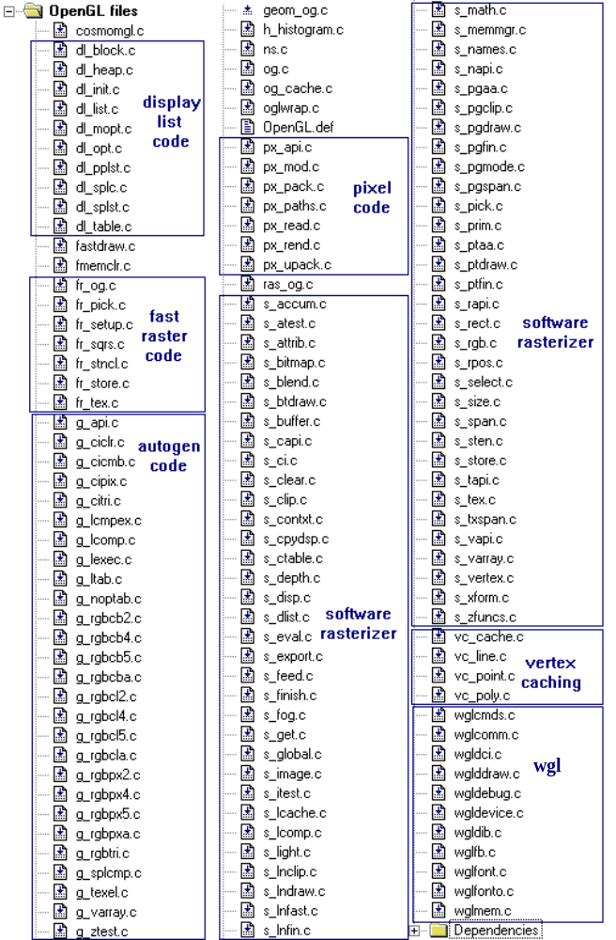

Below is a brief description of some of the major code sections:
Fast Raster (raster) Code uses run time code creation to speed up software rasterization. At run time, the raster code generates a memory buffer of vectorized Intel machine language, based on the context, primitive and state. The buffer is then pointed to and executed. This avoids loop overhead (among other things) and provides for very fast execution. Naturally, not all rendering conditions can be handled and in those cases, the generic, slower, software rasterizer is used as a fallback. The raster code is implemented in a similar fashion to a hardware device driver, by replacing the rendering procedure tables with raster function pointers.
Software Renderer (soft) is the code responsible for generic rendering, including both the geometry pipe (lighting, transforms, clipping, etc.) as well as a generic rasterizer. It is here that the fall back rasterizer resides for when the fast raster code cannot be used.
Automatically generated code comprises a large percentage of the OpenGL pipeline. This code, generated at compile time, is produced automatically from a set of UNIX tools such as awk. Since many operations are similar, for example span fills for 4, 8, 16 and 32 bit pixels, the compile time code generator produces all the various functions that slightly differ between them, but are separated in order to provide maximum speed. It is here that the actual API function and display list interface code is produced as well.
Pixel Code is actually composed of a large set of routines. All pixel operations (ReadPixels, DrawPixels, CopyPixels), bitmap rendering as well as texture re-formatting are performed here; storing, reading, scaling, zooming, blending, packing, unpacking, lut table management, arithmetic operations and some span operations.
Display List Management which is responsible for the display list calls, heap management, list sharing, list compilation, validation and list optimizations. In fact, device drivers can perform implementation specific display list optimizations by providing proprietary list management code and replacing the generic process in the OpenGL process table.
Vertex Caching can be used to build up the point, line, triangle and polygon primitives between glBegin and glEnd calls. All the memory management functions, validation and primitive specific processing occurs in this module.
Wgl code provides for context management, Mutex synchronization, memory management of drawables, thread management, and procedure table initialization based on registry validation and PFD checks. It is here that a determination is made of which what procedures are loaded into the API dispatch tables and whether Microsoft OpenGL is used, or the SGI OpenGL is used.
ICD code is specifically designed for implementing the Microsoft ICD mechanism. This code, which interfaces with the 2D driver, provides a variety of required services in order for the display to share access with Windows.

Sample Driver Structure (S3)

Below is a brief explanation of the sample driver directory structure. Because last minute changes were made to the DDK, be sure to check the release notes included with this distribution (and the actual code), to determine the final directory contents and structure. The material below is intended as a guide based on the information available when this documentation was written.
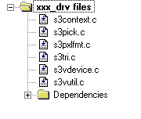

Directories
The DDK directory structure is composed of oglpc (shown below) and ogtst.

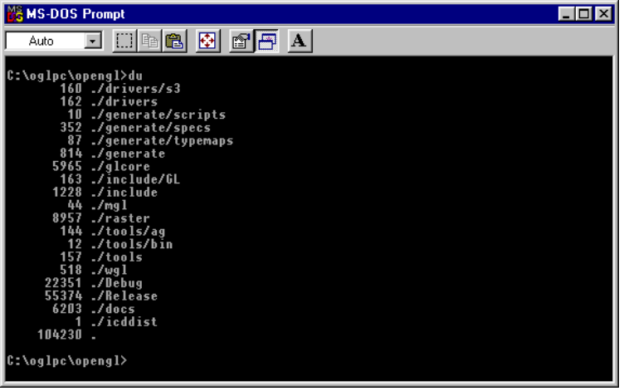

drivers/s3
This directory contains the sample S3 driver for reference.

generate
This directory generates compile time code. This directory is Unix dependent.

glcore
This directory contains the core geometry pipeline, plus rasterization for lines, pixels, bitmaps and pixel rectangles. Files preceded with dl_ refer to display list functions. Files preceded with g_ refer to generated files. Files preceded with px_ refer to functions at the pixel level. Files preceded with s_ refer to software functions. Finally, files preceded with vc_ refer to vertex caching functions.

include
General location for all non-public include files required to build OpenGL DDK.

include/GL
All publicly exposed OpenGL include files reside here.

icddist
Contains the ICD code for the 2D driver. The file ogls3v.asm contains constants and fallback routines required by ogl.obj. Change this file as needed. The file ogl.obj contains the DIB_Control dispatch control (see discussion under recipe of ICD).

Mgl
This directory contains special code to interface between the SciTech MGL and Cosmo OpenGL in order to render directly to MGL fullscreen surfaces with maximum performance.

Raster
This directory contains the software triangle rasterizer. The IHV will not need to modify these files.

Tools
Tools required to build the OpenGL library. Currently, some scripts to make dependencies and other makefile scripts are present.

Wgl
This directory contains the wgl functions used in the software rasterizer. If an ICD is present, the wgl API functions are picked up from the Microsoft OpenGL, but part of the implementation is done here. Either the file iccmds.c or wglcmds.c is used, depending on whether we are building and ICD (icdcmds.c) or a standalone (wglcmds.c) library.

Recipe for an ICD
.
.
.
.
.
..
.
.
.

With this version of the DDK you can build an OpenGL dll or an ICD. These builds may be performed using the included makefiles in each directory. Alternately, the VC++ development environment may be used by opening the desired xxxx.mak files using the Open:Project menu item. Note that if the mak files are used in opening projects, the locations of some libraries and include files (such as the SDK) may be located at different places on your hard disk(s) than here at SGI. As such, the first step in using these files will be the resolution of paths to all necessary files in the project.
Note that this DDK contains three VC++ 4.2 mak files for developing OpenGL. The opengl.mak will build the software only version of this dll, while the S3VOGL.mak will build the sample S3 accelerated version. The S3VICD.mak will build the ICD.

The 6 steps to creating your ICD
Let’s begin by discussing the steps required to produce your ICD. Some of the steps are easy, while others can be more time consuming. Although an ICD may be put together in many ways, the recipe below is intended to be a basic overview of a reasonable development path.
Note that to build an ICD, one additional step is initially required. The file glcltpt.c from the Microsoft distribution (in the client directory) should be copied into the SGI tools/msfmt directory. Use nmake –f makefile.95 to build the include file g_disp_dt.h. This include file contains the dispatch table required specifically for an ICD.

Collect Information
- Obtain the Microsoft ICD Kit. Contact swright@microsoft.com for more information.
- Decide on a name for your driver (such as s3vdrv.dll). Currently, SGI does not implement a client/server model. As such, the only IHV dll would be s3vdrv.dll without a s3vogl.dll counterpart.

Modify the 2D Driver (kernel mode)
- Edit the registry and put in your driver name (such as s3vogl.dll). This change should occur in location HKEY_LOCAL_MACHINE/SOFTWARE/Microsoft/Windows/CurrentVersion/OpenGLdrivers of the registry. The registry entry is referenced in wglcomm.c in function queryRegistry. This registry entry contains keys that correspond to driver names. The key entry is the driver name, as returned by the ExtEscape call (for example S3Virge). The string value that corresponds to that key, is the name of the ICD library that OpenGL32.dll will load when that specific driver is found present (s3vogl.dll in our case).
- 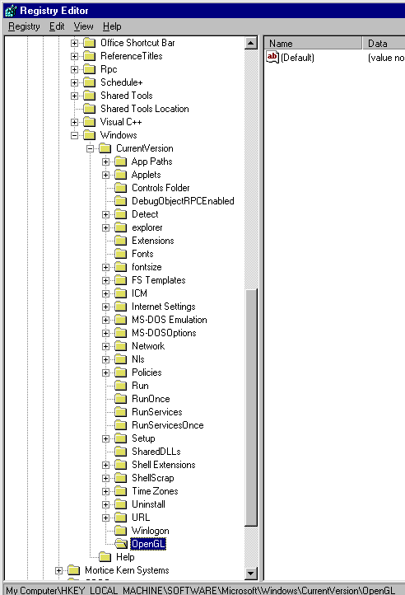Modify the 2D driver to indicate the presence of your driver. This is accomplished by providing the GDI OPENGL_GETINFO Escape and map/unmap registers control. As shown below, this DDK provides a sample implementation for this access to DIB_Control in ogl.obj. Constants for this file and the register map/unmap logic are provided in ogls3v.asm and should be modified as necessary. The graphics driver’s Control function should dispatch to OGLDIB_Control instead of DIB_Control. The OGLDIB_Control dispatches internally to DIB_Control. (If you are a Microsoft ICD licensee, the source for this function is available.) You are now at a point where you can produce a software only ICD, depending on your compile-time options.
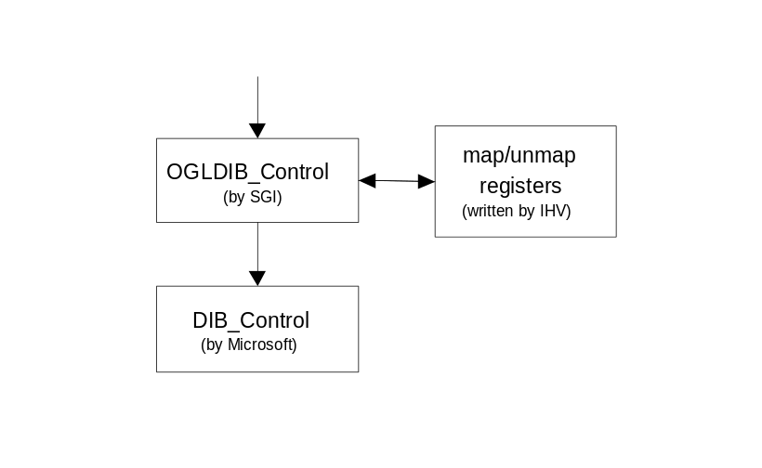

Provide Basic Hardware Access
- Set up an appropriate working directory for your driver development under the drivers directory. By placing your working driver development folder under the drivers directory, you may make use of the SGI drivers/makefile.
- Implement map and unmap registers for use by the kernel mode software, ogl.obj. An example can be found in the ogls3v.asm file.
- It is also necessary to modify the driver to handle exclusive access for the device. This functionality provides for synchronization with the GDI, context register swaps and locking. In Win/NT mutual exclusion is required (although you may have to invent your own). In WIN95 you may use inSrcBlt, if it provides enough exclusion. This is documented in the VDD documentation in the Win95 DDK. You are now done with the kernel work.
- Provide a function for the initialization and release of the 3D hardware. The 3D initialization function (__glS3VSetupFor3D), located in the sample driver in s3vutil.c loads the appropriate registers for 3D rendering based on the current rendering state (fog, blending, etc.). The release function (__glS3VCleanupAfter3D) does just what it sounds like, releasing the 3D hardware.

Add wgl functions
- Provide a __glDevice structure which provides the necessary hooks for your driver. These entry points will provide the necessary redirection to the IHV replacement functions for device specific wgl functionality. As you write the functions described below, insert their entry points into the __glDevice structure so wgl can find your code. As a starting point, reference the code in wglDevice.c.
struct __glDeviceStruct __glS3VDevice = {
__GL_BACK_BUFFER_MASK | __GL_DEPTH_BUFFER_MASK, /* bufferFlags */
__GL_ALLOCATE_HW_TEXTURE, /* textureFlags */
__glLookupTextureFormat, /* lookupTextureFormat */

__glS3ProcessAttach, /* devProcessAttach */
__glS3ProcessDetach, /* devProcessDetach */
NULL /*__glS3ThreadAttach*/, /* devThreadAttach */
NULL /*__glS3ThreadDetach*/, /* devThreadDetach */
NULL, /* devSignal */

__wglS3GetPixelFormat, /* devGetPixelFormat */
__wglS3InvalidatePixelFormatList, /* devInvalidatePixelFormatList */

__glDDrawInitTextureManager, /* devInitTextureManager */
__glS3VCreateContext, /* devCreateContext */

__wglFBInitDrawable, /* devFBInitDrawable */
__wglDIBInitDrawable, /* devDIBInitDrawable */
__wglDDrawGetDisplayMasks , /* getDisplayMasks */
__wglFreeBuffers, /* freeBuffers */
__wglDDrawUpdateDrawablePalette, /* updatePalette */
__wglDDrawSwapBuffers /* swapBuffers */
}
- Specify (and add as available) pixel formats your hardware supports. This is set in the PIXELFORMATDESCRIPTOR. An example may be found in s3vpxlfrm.c. As can be seen in the sample driver, two functions need to be provided; wglS3InvalidatePixelFormatList and wglS3GetPixelFormatList. These functions, which are referenced from the OpenGL wgl code, are used to obtain or invalidate the PFD. After writing these two functions, update the appropriate entries in your __glDevice structure.
- Provide a function to Create Context. The primary function of this routine is to load a default graphics context (gc), which is composed of allocating memory for the gc as well as loading of the device specific gc procedure tables . An example may be found in the sample device driver in s3vcontext.c. Further reference may be found in the OpenGL code s_export.c. The routine should call the OpenGL routine glEarlyInitContext to insure sufficient data is loaded into the context to be valid. Also note the structure of the hardware-specific context (in s3vcontext.h). Note that the first element in the structure is a __Glcontext. This has to be the first element, so we can freely cast between pointers to __Glcontext and your hardware-specific context.

Add 3D Accelerated Functions
- Provide the hooks to accelerate primitives that your hardware handles, one by one. Insert your particular function name into the function InitFnPtrs, so that your device specific function will be called as appropriate. In deciding what functions to accelerate, refer to s_pick.c. For example, if your hardware handles points, insert your own function for point drawing, instead of defaulting to the generic function. In cases where the hardware is unable to perform acceleration, such as indexed color antialiased points, default to the generic functions to use software rendering. Please note that your code should check modeFlags to see what states are enabled. These modeFlags are validated sets, that your code can use to check the current rendering state. In the example below, the hardware does nothing and passes control to the generic point renderer.
- Provide functions for texture management. These functions provide for the management of texture memory, including loading of texturing to video memory, any required internal texture format translations, and scaling. The sample driver uses DirectDraw for global texture management, but many IHVs may want use provide their own mechanism. See the chapter on Texture Management for details on the sample S3 manager.
void __glS3VPickPointProcs(__GLcontext *gc)
{
__glGenericPickPointProcs(gc);
}
- Add state management functions.

Testing your ICD
- Test your ICD. The DDK provides a full suite of QA software for testing your new driver. This test code, collectively called ogtst, is composed of a suite of routines to test all the standard operations of OpenGL. Although not a replacement for the full Conformance tests by the OpenGL ARB, ogtst does provide an excellent starting point to insure a quality driver.
- Benchmark your ICD. Several benchmarks are publicly available which will test the performance of your driver and hardware. The best known (and quoted) benchmarks are glperf, Glaze, Viewperf, Sense8, Gemini (gvf & gvr) and trilist. These benchmarks range from comprehensive and complex (such as glperf), to quick and easy (such as trilist). The locations of these benchmarks are listed in the back of this guide under references.
.
.
.
.
.
.
..
.
.

PICKPROCS
Function Name | Purpose | Location
__glGenericPickBlendProcs | Raster blending modes | blend.c
__glGenericPickColorMaterialProcs | Material attribute modification | s_light.c
__glGenericPickTextureProcs | Variety of texture functions | s_pick.c
__glGenericPickCalcTextureProcs | Calculate texture coordinates | s_pick.c
__glGenericPickFogProcs | Fog, pixel and vertex | s_pick.c
__glGenericPickTransformProcs | Matrix push/pop/identity | s_pick.c
__glGenericPickParameterClipProcs | not currently used for in conventional fashion | s_clip.c
__glGenericPickPointProcs | Point rendering | s_pick.c
__glGenericPickTriangleProcs | Triangle rendering | s_pick.c
__glGenericPickLineProcs | Line rendering | s_pick.c
__glGenericPickRenderBitmapProcs | Raster bitmap rendering | s_pick.c
__glGenericPickClipProcs | Line & triangle clipping | s_pick.c
__glGenericPickBufferProcs | Buffer locks | s_pick.c
__glGenericPickStoreProcs | Pixel writes | s_store.c
__glGenericPickSpanProcs | Span Rendering | s_pick.c
__glGenericPickVertexProcs | Vertex clip, validate, light & texture | s_vertex.c
__glGenericPickVertexArrayEnables | Vertex array flags for clip, validate, light & texture | s_varray.c
__glGenericPickVertexArrayProcs | Vertex array clip, validate, light & texture | s_varray.c
__glGenericPickPixelProcs | Per pixel operations | s_pick.c
__glGenericPickDepthProcs | Pixel & span depth test | s_pick.c
__glGenericPickAllProcs | Loads all generics | s_pick.c
__glGenericDlistOptimizer | List optimizer for retained lists | dl_opt.c
__glGenericDlistCompiler | List optimizer for compiled lists | s_dlist.c

Pickprocs is located in the OpenGL source tree in s_pick.c. As described in the Recipe for an ICD chapter, there are a variety of generic pick procedures the user can fall back on. These generic functions are:

Sample Driver Functions
.
.
.
.
.
..
.
.
.

S3vcontext.c

WaitIdle
Although this is a nop in software, this function is provided for synchronization (i.e. when switching from the 2D core to the 3D core). This function is for future use.

CheckViewport
This function is used to determine if scissor tests can be avoided, thereby saving some processing time and then revalidates the context.

ApplyViewport
This function loads the new viewport height into the gc raster position.

ApplyScissor
Performs the CheckViewport scissor requirement test and revalidates the gc.

ChangeDrawableSize
Reloads the context to reflect the specified new width and height.

ChangeDrawableLocation
Reloads the context to reflect the specified new position as well as the width and height.

LockBuffers
This is a hook for the non-advertized wglLockBuffers() API function (not provided in the ICD case). wglLockBuffers() provides a way for the application programmer to lock the drawable buffers, in order to minimize the overhead caused by multiple Lock/Unlocks issued at the primitive level.

UnlockBuffers
This is a hook for the non-advertized wglUnlockBuffers() API function

LockDevice
Prepares the device for 3D rendering by loading the device specific context and calling __glS3VSetupFor3D.

UnlockDevice
Releases the device from 3D drawing mode. Some minimal housekeeping with the device specific context is required, but this function calls __glS3VCleanupAfter3D to do most of it’s work.

Finish
This is a pass-through routine to Flush, below.

Flush
Forces a flush of the vertex cache.

InitFnPtrs
This important function loads the device specific function pointers. For example, in the code below:
gc->procs.pickSpanProcs = __glGenericPickSpanProcs;
gc->procs.pickStoreProcs = __glGenericPickStoreProcs;
gc->procs.pickTextureProcs = __glGenericPickTextureProcs;
gc->procs.pickCalcTextureProcs = __glGenericPickCalcTextureProcs;
gc->procs.pickTriangleProcs = __glS3VPickTriangleProcs;
gc->procs.pickVertexProcs = __glGenericPickVertexProcs;
gc->procs.pickVertexArrayProcs = __glGenericPickVertexArrayProcs;
gc->procs.pickDepthProcs = __glGenericPickDepthProcs;

the (S3) device specific triangle rendering procedures are loaded into the context procedure table as indicated. It is here that your hardware specific functions should be specified.

InitBuffers
Initializes the context-side buffers structures.
Buffers are divided into two parts. The context-side part, and the OS-side part (also called the drawable, for historical reasons).
The context-side part of a buffer, keeps context-specific information needed in order for the core and the your driver specific code to render to the buffer. Color scaling and similar information belongs here.
The OS-side part of the buffer is responsible for the allocation / deallocation / locking / unlocking and general memory-management control of the buffers. In general, any buffer information that is not window or system dependent, should go to the context-side part of the buffer.
The nomenclature is the similar to the pick routines. For example __glInitRGB() initializes a generic RGB color buffer. __glS3InitRGB() initializes an S3 specific color buffer initialization routine.
Note that the (possibly device specific) depth buffer scaling or color-depth specific scaling belong to the context-side initialization.

SwapBuffers
This is the context-side of the buffer swap. It contains hardware-specific or core code that needs to update context-side state when a buffer got swapped.
The actual buffer swap is handled in wgl, since it is treated as a part of the window system.

DestroyContext
Frees buffer memory (frame, accumulation, depth and stencil) for the specific gc states such as lights, shader, attributes and such.

LoseCurrent
This operation is executed right before a MakeCurrent operation. This is the place to store any context specific state information before the next context is made current.

MakeCurrent
Make this context the current context for this process. Forces validation, sets a large variety of gc states and initializes the buffers.

ShareContext
Provides for the sharing of retained lists and textures across contexts. Private list states are destroyed.

__glS3VCreateContext
Allocates memory for, and creates a new context without making it current. If host memory cannot be allocated for the context, the function will fail.

s3vpick.c
This is certainly one of the most important files you need to be aware of. This file contains all the methods for each primitive in the S3V sample code. As such, routines for various lines, triangles, and other primitives are in this file. See below for a brief description of each function. Refer to s_pick.c for the generic functions.

__glS3VPickPointProcs
Contains the code to set the procedures required to handle point primitives.

__glS3VPickLineProcs
Contains the code to set the procedures required to handle line primitives.

__glS3VPickRenderBitmapProcs
Contains the code to set the procedures required to handle bitmap primitives.

__glS3VPickClipProcs
Contains the code to set the procedures required to handle clipping of lines and triangles.

__glS3VPickCalcTextureProcs
Contains the code to set the procedures required to calculate texture values.

__glS3VpickTextureProcs
Contains the code to set the procedures required to calculate texture values for mip mapping, blending, filtering, scaling and more.

__glS3VpickFogProcs
Contains the code to set the procedures required to calculate fog (vertex and point).

__glS3VpickBufferProcs
Contains the code to set the procedures required to lock and unlock the various draw and aux buffers. This code also sets the masks for front and back drawing buffers, depending on the current settings.

__glS3VpixelProcs
Contains the code to set the procedures required to store pixels. Note that this is a fairly complex task dealing with multiple buffers and color clamping.

__glS3VpickDepthProcs
Contains the code to set the procedures required to perform depth testing in the Z-buffer.

__glS3Vvalidate
Contains the code to set the procedures required to dispatch the procedure table.

__glS3VpickAllProcs
Contains the code to set the procedures required to load all generic procedures into the proc table.

__glS3VpickVertexProcs
Contains the code to set the procedures required to perform vertex operations, such as clipping, validation and lighting.

__glS3VpickVertexArrayProcs
Contains the code to set the procedures required to perform vertex array operations, such as clipping, validation and lighting.

__glS3VpickBlendProcs
Contains the code to set the procedures required to perform blending operations.

__glS3VpickColorMaterialProcs
Contains the code to set the procedures required to change material properties.

__glGenericPickColorMaterialProcs
Contains the code to set the procedures required to perform material opeations.

__glS3VpickTriangleProcs
Contains the code to set the procedures required to render triangles.

s3vpxlfmt.c
This file is responsible for setting up the pixel format descriptors (PFDs) available in the hardware and is referenced by the OpenGL wgl code wglpxlfmt.c. The PFD is as follows:

__wglS3InvalidatePixelFormatList
PIXELFORMATDESCRIPTOR pfd =
{
sizeof(PIXELFORMATDESCRIPTOR), // Structure size
1, // Structure version number
PFD_DRAW_TO_WINDOW | PFD_SUPPORT_OPENGL, // Property flags
PFD_TYPE_RGBA, // Use RGB color, not indexed
24, // Number of color bits
0, // Red bits
0, // Red shift
0, // Green bits
0, // Green shift
0, // Blue bits
0, // Blue shift
0, // Alpha bits
0, // Alpha shift
0, // Accum bits
0, // Accum red bits
0, // Accum green bits
0, // Accum blue bits
0, // Accum Alpha bits
32, // 32-bit depth buffer
0, // Stensil bits
0, // Auxillary buffers
PFD_MAIN_PLANE, // Main layer type - only type supported by NT
0, // 23 Reserved. Must _ALWAYS_ be set to 0 (zero)
0, // 24 Layer mask - unsupported
0, // 25 Visible mask - unsupported
0 // 26 Damage mask - unsupported
} ;
This function frees the PFD memory and sets the wglPixelFormats to dirty, so on the next getPFD, memory will be allocated and the PFDs picked up again.

__wglS3GetPixelFormat
This function is responsible for returning the PFD structure for a specific pixel format index.
It is also responsible for lazily allocating the list of pixel formats valid for the current screen format.
Note that calls are made to wgl mutex locking and unlocking to prevent multiple simultaneous wgl calls to the driver. These mutex locks insure that the driver responds to a single wgl inquiry.

s3vtri.c

__glFRSetupRho

__glS3VFlatZTri

__glS3VFlatTri

__glS3VLirpZTri

__glS3VLirpTri

__glFRComputePolygonRho

__glFRSetupRho

s3vdevice.c
This file provides for functions to manage the most basic access to the hardware; register mapping and hardware-specific TLS management. winproc calls

__glS3ProcessAttach
This function invokes register mapping and validates the thread's thread local storage (TLS) slot.

__glS3ProcessDetach
As one would expect, this function frees up the TLS and unmaps the registers.

__glS3ThreadAttach
This function provides for the allocation of the thread area and loads the pointer into the TLS.

__glS3ThreadDetach
This function clears thread memory allocation pointer in the TLS.

s3vmap.c and s3vmapicd.c
These files provide for the lowest level of interface to the hardware. In these routines, the routines make the hardware available and perform necessary setup for 3D rendering.

__glS3VMapRegisters
This function is responsible for contacting the kernel to map the registers of the graphics hardware to our address space. This can be done two different ways, depending if you have a Microsoft ICD license or not:
If you do have an ICD license, you should use the GDI ExtEscape call that you provided as a callback from the ogl.obj file. Example code is given in the s3vmapicd.c file.
On the other hand, if you do not have an ICD license, you should use a VxD to do the same operation. Example interface code is given in s3vmap.c. The example VxD source code is given in the oglpc/opengl/icddist/vxd directory.

__glS3VUnmapRegisters
This function contains any operation (such as calling the GDI ExtEscape) that may be needed to remove the hardware registers from our address space.

__glS3VSetupFor3D
This function is responsible for setting up the hardware in the appropriate manner to provide 3D rendering in the current OpenGL state. An example of the state variables that need to be set (or verified that they are set) are fog, Z test mode, texture blend mode, mipmap settings, clip enable and all the other hardware specific functionality of the device.

__glS3VCleanupAfter3D
This function releases the 3D hardware. In the case of the sample S3 driver, this is accomplished by the passing of a nop, waiting for an empty fifo and a verifying readback via WaitForEngineIdle.

.
.
.
.
.
.
..
.
.

Texture Manager
A sample texture manager is located in the drivers/ddraw directory in the DDK. The texture manager provides all the control mechanisms for creating, deleting and managing texture memory in OpenGL for Windows. Let’s review each function below.

__glDDrawInitTextureManager
Allocates memory and creates a Ddraw surface for texture management.

__glDDrawReleaseTextureManager
Releases the Ddraw object and frees the library if the number of remaining textures is zero.

__glDDrawInvalidateTextureManager
This routine sets all texture priorities as invalid. This is used whenever texture priorities change.

TexMgrCreateTexture
Adds the texture to the list of active texture objects.

TexMgrDeleteTexture
Removes the texture from the active texture list.

TexMgrMakeResident
Forces the texture to be loaded into VRAM. In the sample driver, this does not perform an operation.

__glDDrawCreateTexture
Sets up the texture structures and calls TexMgrCreateTexture.

__glDDrawFreeTexture
Frees up the texture structure memory and calls TexMgrDeleteTexture.

__glDDrawTextureMakeResident
Loads the texture into memory, if it fits. Also determines association of mip level surfaces with each mip level.

__glDDrawMipMapSlurp
This routine is responsible for moving textures into VRAM. If your hardware uses a unique method of storing textures, such as separate locations for even and odd scanlines, this is the place to put the translation code in. In the sample DDraw driver, this function does not perform any operations.

__glDDrawMipMapSlurpSubImage
This routine is responsible for moving texture subimages into VRAM. Like above, this is the place to put any unique translation code if your hardware stores textures in a novel way. In the sample DDraw driver, this function does not perform any operations.

Comments
These functions interact with the glcore functions. For example, texel reads (called extracts in OpenGL) may be found in s_texel.c under the glcore directory. However, setting up the memory to hold the textures (and move them into VRAM) are in the functions above.
.
.
.
.
.
..
.
.
.

Known Bugs and Limitations

Software Bugs
- Outline fonts drawn via wglUseOutlineFonts() with extrusion produce correct geometry but the edge normals are incorrect.
- Color index rendering to a window only works in 8 bit framebuffer modes. Color index rendering to an 8-bit DIB works correctly regardless of the framebuffer setting.
- Rendering to the front buffer with an 8-bit pixel format (i.e., 8 bit color index rendering or 8 bit RGB rendering) requires the identity palette.
- There is no support for destination alpha.
- Polygon offset does not work when the polygon mode is GL_POINT or GL_LINE. (i.e., polygon offset only works for polygon mode GL_FILL.)

S3 Bugs
- The functionality is incomplete. There are problems with texturing--for example, mipmapping doesn't work. Also, some features such as point rendering, 24 bit pixel formats and alpha blending, are not implemented in the driver (software paths are used instead)..
- Flight and skyfly do not work correctly.
- Conformance does not pass.
- Textures with a width or height greater than 128 texels may not work correctly when rendered with perspective correction.
- Textures that aren't square may not work correctly.
- Rendering to DIBs doesn't work correctly.
Report bugs to: win-opengl@sgi.com

Tested Hardware
OpenGL for Windows has only been tested on the following graphics chip sets:
- GS 1682
- Matrox Mystique and Millenium
- S3 968 and Virge/VX
- 3DLabs Permedia NT and Permedia II
- Rendition Verite

Extensions
• The following extensions are implemented in SGI's OpenGL library for Windows:
- GL_SGI_cull_vertex
- GL_SGI_compiled_vertex_array
- GL_SGI_index_array_formats
- GL_SGI_index_func
- GL_SGI_index_material
- GL_SGI_index_texture

The interface to these extensions may change after they have been reviewed by the OpenGL ARB. Also, some of them may become EXT extensions (i.e., use EXT as the suffix instead of SGI) after they have been reviewed.

Non-optimized Paths
The following paths are not optimized in the software renderer:
- polygon offset (i.e., glEnable(GL_POLYGON_OFFSET_EXT))
- drawbuffer front and back (i.e., glDrawBuffer(GL_FRONT_AND_BACK))
- blending functions other than GL_ZERO, GL_ONE, GL_SRC_ALPHA, GL_ONE_MINUS_SRC_ALPHA (see glBlendFunc()), except on systems with MMX extensions in 16-bit framebuffers.
- texture borders
- texture filters other than GL_NEAREST (see glTexParameter())
- stencil, stipple, and alpha test

For the most recent details of Known Bugs and Limitations, see our Web page at: http://www.sgi.com/Technology/OpenGL/Windows/releasenotes.html#bugs
.
.
.
.
.
.
..
.
.

Glossary
- __GLcontext is an object with data members (e.g. validateMask) and methods (e.g. procs.validate).
.
.
.
.
.
..
.
.
.

References

Documents
OpenGL Installable Client Driver, Reference Guide, 1995, distributed as part of the Microsoft ICD kit. This document contains necessary information for creating an ICD.
Virge/VX Integrated 3D Accelerator, published by S3 Inc. This reference is a helpful to understand the sample S3 code. There are some reported inaccuracies in the documentation, so refer to the code (and not the manual) when in doubt.
OpenGL: An Update for Gamers, published by Game Developer Magazine and available at at www.gamasutra.com. This document provides an overview of the SGI implementation and briefly discusses performance issues.

Benchmarks
Gemini www.gemtech.com/rwb/index.html
Glaze www.vsisinc.com/software/softvlt.html
glperf www.specbench.org/gpc/opc.static/glperf~1.html
Sense8 www.sense8.com/resources/results.html
trilist www.3dpipeline.com
ViewPerf available from specbench listed above

